Flygerians Unit 1-14 Bournemouth Close Peckham Palms SE15 4PB The Flygerians
London's first Black women-led business hub, featuring Nigerian street food spot The Flygerians, a firm favourite with TUCO as they have been keynote speakers at Winter Conference and hosted cooking classes in the past.
Sisters Jess and Jo Edun have been cooking since they were kids, helping their grandmother with huge, family cookouts. They've now bought their street food skills to Peckham Palms arcade. The Flygerians' specialty is their jollof box, which comes with efo riro spinach stew, chicken suya, beef suya, squid, or fried fish. Don't miss the chin’offee pie for pudding, a chin chin-based dessert with bananas, caramel, whipped cream and topped with a sprinkling of Milo.
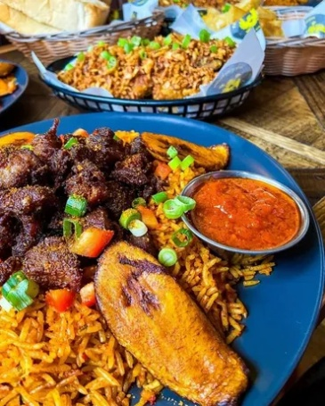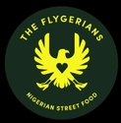
Why it’s worth visiting:
- Street food roots to permanent, scalable concept: The Flygerians began as pop-ups and street food activations before establishing a permanent site in Peckham—demonstrating a clear growth pathway from informal trading to a fixed, revenue-generating venue.
- Strong founder-led brand with cultural authenticity: Founded by sisters Jess and Jo, the concept is deeply rooted in Nigerian heritage and storytelling, reinforcing how founder identity and authenticity can drive brand loyalty and differentiation.
- Bold, flavour-led menu with broad appeal: Core dishes such as jollof rice, suya, plantain and grilled meats deliver high-impact, recognisable flavours that resonate with both diaspora communities and new audiences.
- Accessible entry point to Nigerian cuisine: The menu balances authenticity with familiarity (e.g. “Naija fish & chips”, wings, rice bowls), making it easier for first-time customers to engage—an important consideration for introducing global cuisines into campus environments.
- Experience-led, social dining environment: Located within Peckham Palms, a hub of independent businesses, the venue combines music, cocktails and vibrant atmosphere, positioning food as part of a wider cultural and social experience rather than a standalone transaction.
- Flexible, event-ready food offer: The concept has delivered catering for major brands and events, showing strong capability in scaling across pop-ups, corporate catering and hospitality activations.
- Menu design supports operational efficiency: A structure of “small chops” and “big chops” enables modular ordering, portion control and cross-utilisation of ingredients, supporting both speed and consistency in service.
- Cultural positioning and community integration: Being part of a space that champions Black-owned businesses adds a layer of purpose and identity, demonstrating how venue context and community alignment enhance brand value and customer engagement.
- Application for university catering:
Develop modular menus (small plates + mains) for flexibility and upselling
Introduce accessible global dishes that bridge familiarity and authenticity
Create experience-led dining spaces (music, culture, themed environments)
Utilise pop-up and event catering formats for campus activations
Build founder/story-led concepts to strengthen engagement and identity

Enish Restaurant Oxford Road Oxford Street – EnishGlobal
Since 2013, Enish has been redefining Nigerian cuisine from London to Dubai and beyond. Each location celebrates the rich flavours and vibrant spirit of West Africa served with modern flair and world-class hospitality.
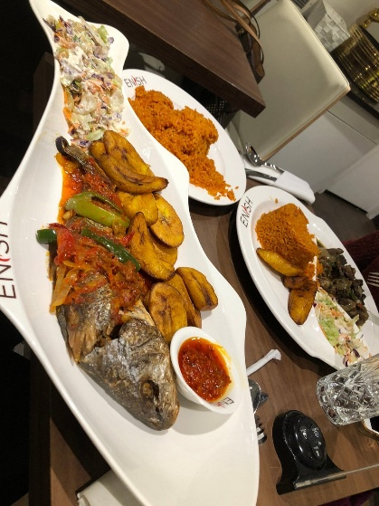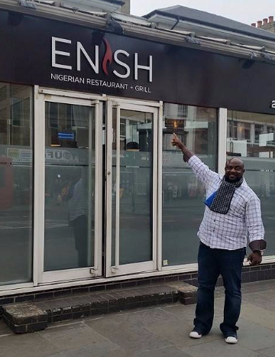
Why it’s worth visiting:
- Established, scalable Nigerian brand: Enish is one of the UK’s most recognisable Nigerian restaurant groups, with multiple sites across London and beyond. It demonstrates how a traditionally rooted cuisine can be standardised and scaled while maintaining authenticity—highly relevant for institutional catering models.
- Core menu built on proven demand: The offer centres on staple dishes such as jollof rice, egusi soup, pounded yam, suya and grilled meats. This highlights the value of a tight, repeatable core menu that drives consistent demand and simplifies production.
- High-volume, batch-friendly cooking model: Many dishes are stew-based or grilled, making them ideal for batch cooking, holding and rapid service. This supports efficiency during peak periods—particularly applicable to university lunch services and high-footfall environments.
- Strong value perception and portion size: Generous portions and bold flavours create a strong value proposition, aligning with student expectations around price, satisfaction and comfort food appeal.
- Authenticity that builds loyalty: Enish delivers traditional Nigerian flavours without dilution, attracting both diaspora communities and new customers. This demonstrates how authenticity can be a commercial strength, not a barrier.
- Flexible dining formats: Suitable for dine-in, takeaway and delivery, the model shows how one menu can operate across multiple channels, increasing revenue opportunities and accessibility.
- Clear brand consistency across sites: Standardised menus, consistent quality and recognisable branding provide a blueprint for multi-site catering operations, including campus outlets or franchise-style models.
- Cultural familiarity and growing demand: Reflects the increasing prominence of African cuisine within the UK food landscape, particularly in diverse urban and student populations—supporting menu diversification strategies.
- Application for university catering:
Introduce core African dishes (e.g. jollof rice, stews, grilled meats) into daily menus
Develop batch-cooked, high-efficiency meal components for peak service
Use set meals or combo offers to drive value perception and throughput
Incorporate into cultural food weeks or rotating global menus
Adapt for grab-and-go formats (rice boxes, protein + sides)

Chuku’s 274 High Road, Tottenham, N15 4AJ (17:30-22:30) Nigerian Restaurant London | Chuku’s in Tottenham

The world's first Nigerian tapas restaurant ran by a brother-sister duo on a mission to share and celebrate the best of Nigerian culture. Experience Nigerian flavours, served tapas-style, alongside the best afrobeats vibes.

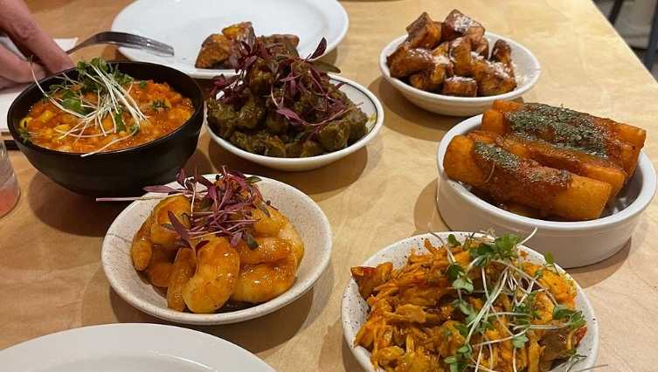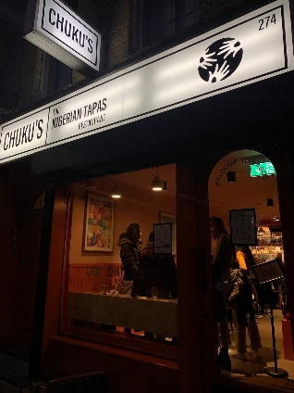

Why it’s worth visiting:

- Pioneering “Nigerian tapas” concept: Chuku’s has successfully repositioned Nigerian cuisine into a small-plates format, making it more accessible to a wider audience. This approach demonstrates how traditional dishes can be restructured into shareable, flexible portions that align with modern dining behaviours—particularly relevant for student markets.
- Menu innovation without losing authenticity: The menu includes dishes such as jollof quinoa, suya meatballs and plantain-based plates, showing how core flavours and heritage can be retained while adapting formats and ingredients. This is a strong example of balancing authenticity with innovation to broaden appeal.
- Strong brand storytelling and identity: Built around the narrative of “chop, chat, chill,” Chuku’s integrates food with culture, music and community. This reinforces how clear brand positioning and storytelling enhance the overall customer experience, moving beyond transactional dining.
- Designed for social dining and dwell time: The tapas-style format encourages multiple orders, sharing and longer stays, increasing both spend per head and engagement. This is highly relevant for campus hospitality aiming to create social spaces rather than just feeding operations.
- Appeal to diverse and younger audiences: By modernising presentation and format, Chuku’s attracts both those familiar with Nigerian cuisine and those trying it for the first time—demonstrating how global cuisines can be made approachable without dilution.
- Operational flexibility and menu control: Smaller dishes allow for better portion control, reduced waste and easier menu rotation, supporting both cost management and innovation. This model is particularly useful in environments with fluctuating demand, such as universities.
- Event and experience integration: Chuku’s frequently combines food with cultural events, music and themed evenings, showing how food can act as a platform for wider engagement activities rather than a standalone offer.
- Application for university catering:

Develop small-plate / sharing concepts within food halls or pop-ups
Introduce “global tapas” nights or themed cultural events
Use modular dishes to allow mix-and-match menus and flexible pricing
Create experience-led dining environments that encourage longer dwell time
Incorporate storytelling and cultural context into menus and marketing

2 Nigerian Boys Lamb Street, Spitalfields Market E1 6EA (11:00-15:00) 2nigerianboys
Nigerian Jollof Rice is legendary for its delicious and smoky taste. We serve our legendary rice with Chicken, Beef, Lamb, veggies or Plantain as a combo, super combo or mega combo. Ohh...so delicious!!! Lunch time Jollof rice with Chicken, Beef, Lamb or Spinach. You can garnish with fried plantains (dodo), coleslaw salad, chopped veggies too!

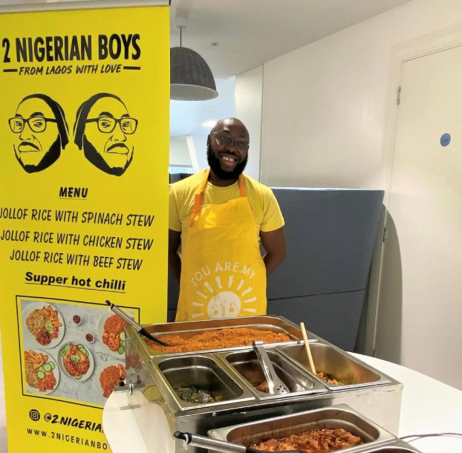
Why it’s worth visiting:
- Single-product excellence (focus drives demand): Built around one core dish—Nigerian jollof rice—this concept demonstrates how doing one product exceptionally well can create strong brand identity, consistency and repeat custom. The offer is simple but highly refined, with combinations of chicken, beef, lamb or plantain.
- High-impact, low-complexity model: A tightly focused menu reduces operational complexity, speeds up service and supports high-volume throughput—particularly relevant for university catering looking to deliver quality at pace.
- Street food format with strong commercial viability: Operating from market environments such as Spitalfields (and expansion into Brixton), the concept shows how location, simplicity and product quality can drive footfall and profitability in busy, transient dining spaces.
- Bold, flavour-led proposition: Jollof rice—known for its rich, smoky and spiced profile—aligns with increasing demand for globally inspired, flavour-forward dishes among younger and urban consumers.
- Clear scalability for catering and events: The format translates easily into bulk production for corporate catering, events and festivals, with the business already delivering across these channels—highlighting its adaptability beyond a fixed site.
- Authenticity with accessibility: Rooted in Nigerian food culture but delivered in a familiar, grab-and-go format, it provides an accessible entry point into West African cuisine for a broad audience.
- Application for university catering:
Ideal for street food markets and campus pop-ups
Strong case for hero dish-led concepts (e.g. one signature product)
Suitable for high-volume lunch offers with minimal complexity
Supports culturally diverse, flavour-led menus with strong student appeal

805 Restaurant (3 venues) 805 Restaurants | Authentic West African Cuisine | Around the UK & Africa
Founded by Mr Frederick and Mrs Damaris James, 805 Restaurants remains family owned. We consider all our regular customers to be part of our family and enjoy satisfying their unique requirements. Visit any 805 restaurant and enjoy the same great food any day of the week or for a special occasion. Each location has a unique decor and ambience, to both welcome and refresh you.
Our food and food quality have been our focus since 2001, when we opened our first restaurant. Every meal is made to the highest standard by our skilled chefs using indigenous ingredients and traditional cooking methods to bring you great-tasting and great-looking food.
Twenty years on, this has not changed. Our menu evokes fond memories and tells the story of Nigerian food, from the well-known Jollof rice to regional soups and our much-loved signature Monika Fish.
EXPERIENCE AUTHENTIC FAMILY RECIPES AT THE Award-Winning West African Restaurant Group
Come and enjoy our much loved recipes, created and perfected by our family for generations. We can’t wait to welcome you.

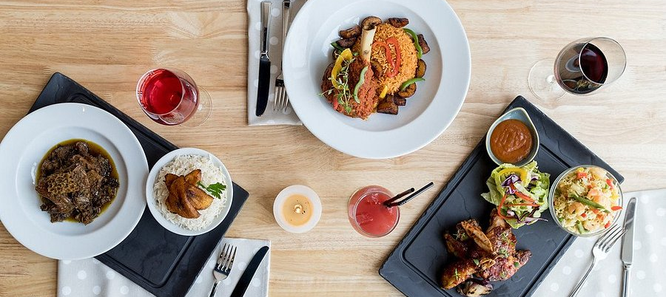

Why it’s worth visiting:
- Proven, high-volume Nigerian dining model: 805 Restaurants have built a strong reputation for delivering authentic Nigerian cuisine in a casual, fast-paced environment. The concept demonstrates how traditional dishes can be operationalised for consistent, high-volume service without compromising flavour.
- Menu simplicity that drives efficiency: The offer focuses on a core range of rice dishes, grilled meats, stews and sides (e.g. jollof rice, fried rice, plantain, pepper soup). This tight structure supports streamlined operations, easier training and faster service times—critical in peak-demand settings.
- Batch cooking and production scalability: Many dishes are prepared in bulk (rice, stews, sauces), allowing for efficient prep, holding and rapid assembly. This model translates directly to university environments where throughput and consistency are key.
- Strong value proposition: Generous portions combined with bold, satisfying flavours create high perceived value—aligning well with student expectations for affordable, filling and flavour-led meals.
- Grill and protein-led appeal: The emphasis on grilled meats (including suya-style flavours) adds theatre, aroma and visual appeal—important drivers of footfall in food halls and open kitchen environments.
- Fast-casual adaptability: The format sits comfortably between restaurant and takeaway, making it suitable for eat-in, grab-and-go and delivery channels. This flexibility increases revenue potential and accessibility.
- Consistent brand execution: Standardised menus and repeatable processes provide a clear framework for multi-site rollout or campus-wide implementation, supporting operational control.
- Broad audience reach: While rooted in Nigerian cuisine, the flavour profile and format appeal to a wide audience, demonstrating how global comfort food can cross cultural boundaries.
- Application for university catering:
Develop rice bowl / box concepts with protein and sides for quick service
Utilise batch-cooked components to improve efficiency during peak times
Introduce grill-led stations to increase engagement and theatre
Offer combo meals to drive value perception and speed of ordering
Integrate into food hall or refectory environments as a high-volume anchor offer

Waakye Joint 440 Streatham High Road London WAAKYE JOINT | uk

The laidback Waakye Joint celebrates starchy, fibre-filled Ghanaian foods such as banku, fufu and kenkey, pairing them with nutritious vegetable soups and stews such as kontomire with beef, fish and turkey. You’ll find it on Streatham High Road, and once inside, your eyes will be immediately drawn to the large, hot food counter. This might be intimidating if you don’t know what to order, but you can’t go wrong with traditional tofi, deep fried turkey tails accompanied with crispy yam fries and a popular spicy shrimp-based hot pepper sauce, shito, a Ghanian condiment made of dried fish, peppers and spice. Their must-try dish is the eponymous waakye, a flavourful combination of rice and beans served with salad, noodles, fried fish, boiled egg, and shito. Expect long wait times but it’s worth it; prices are cheap and you’re served with generous portions that emulate a chop bar (traditional eatery) experience in Southern Ghana. There's two branches - one in Streatham and the other in Tottenham.
A personal favourite is the red red, a classic Ghanaian street food composed of soft black-eyed beans cooked in a rich tomato stew (the colour of which gives the dish its name), with fried sweet plantain.

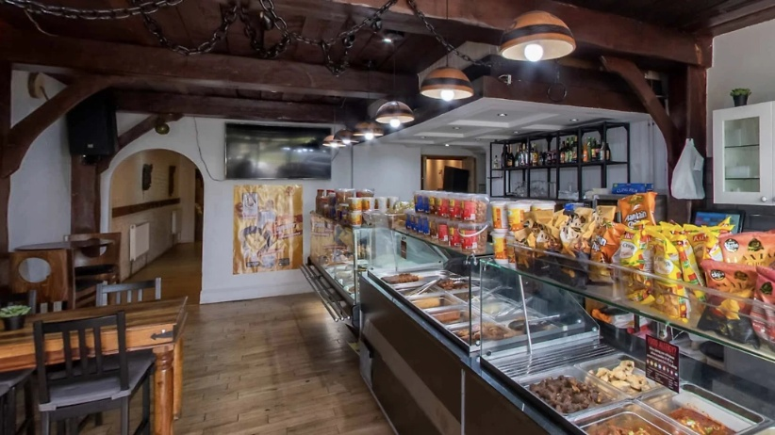

Why it’s worth visiting:

- Authentic Ghanaian “chop bar” experience: Waakye Joint replicates the traditional Ghanaian chop bar format, with a visible counter of prepared dishes and fast, informal service. This offers a clear example of heritage dining translated into a modern London setting, maintaining cultural integrity while remaining commercially viable.
- Hero dish-led concept (clear product identity): The menu is anchored by waakye—a rice and beans dish served with multiple accompaniments (egg, fish, salad, shito). This “meal-in-one” format demonstrates how a single, signature dish can drive brand recognition, simplify operations and increase throughput.
- High-volume, fast-service model: The counter-style service and pre-prepared dishes enable quick decision-making and rapid service, making it ideal for busy, high-footfall environments. This mirrors the operational needs of university catering during peak periods.
- Batch-friendly, cost-effective menu structure: Core dishes such as rice, beans, stews and plantain are highly scalable and batch-produced, supporting consistency, reduced waste and strong margins—key for institutional catering models.
- Broad and authentic menu range: Beyond waakye, the menu includes jollof rice, banku, kenkey and soups—providing a comprehensive overview of Ghanaian cuisine and demonstrating how a core menu can be expanded without overcomplicating operations.
- Strong value and portion perception: Generous portions and affordable pricing create a compelling value proposition, aligning closely with student expectations for filling, flavour-led meals at accessible price points.
- Cultural authenticity as a commercial strength: The unapologetically traditional approach (flavours, formats, service style) attracts both diaspora communities and new audiences, reinforcing that authenticity can drive demand rather than limit it.
- Takeaway-led, flexible consumption model: The concept is well suited to takeaway and quick dining, with many customers opting for grab-and-go—highlighting its relevance for campus retail, food halls and hybrid dine-in/takeaway models.
- Application for university catering:
Introduce hero dish-led offers (e.g. rice + beans + protein combinations)
Implement counter-service formats to improve speed and flow
Utilise batch cooking for staple components (rice, stews, sauces)
Develop high-value meal boxes with multiple elements
Incorporate into street food markets or global cuisine zones

